**A New Vision: Implementing EasyOCR in the Artificial Eye**

**Abstract**

The "Artificial Eye" is an innovative technology aimed at restoring vision for visually impaired individuals and assisting robots in perceiving their surroundings. This paper introduces the concept and potential benefits of this groundbreaking device. People with visual impairments often face challenges in perceiving their environment, leading to reduced mobility and social barriers. To empower the visually impaired and integrate them confidently into society, this project enhances the Artificial Eye with features such as text interpretation.

**Introduction**

This project addresses the fundamental need for visually impaired individuals to interpret text from images independently and accurately, without relying on external assistance. The capability to extract text from images offers a significant step towards improving accessibility to information for the visually impaired. Additionally, it aims to enable them to detect facial expressions for precise responses to environmental cues. Moreover, the ability to recognize the age and gender of individuals enhances interaction and communication. Importantly, for safety and security, the system can identify various actions in the surroundings and respond appropriately. Implementation of this project has the potential to significantly improve the daily lives of visually impaired individuals, offering them newfound independence and opportunities.

**Methodology**

The methodology encompasses several key components, with a focus on utilizing EasyOCR for extracting text from images. EasyOCR is a robust optical character recognition (OCR) tool that can effectively analyze images and convert text into a digital format. By integrating EasyOCR into the Artificial Eye, the system can accurately interpret text from captured images, enabling visually impaired individuals to access information in various formats.

OCR is formerly known as Optical Character Recognition which is revolutionary for the digital world nowadays. OCR is actually a complete process under which the images/documents which are present in a digital world are processed and from the text are being processed out as normal editable text.

OCR is a technology that enables you to convert different types of documents, such as scanned paper documents, PDF files, or images captured by a digital camera into editable and searchable data.

EasyOCR is actually a python package that holds PyTorch as a backend handler. It detects the text from images but in my reference, while using it I found that it is the most straightforward way to detect text from images also when high end deep learning library(PyTorch) is supporting it in the backend which makes it accuracy more credible.

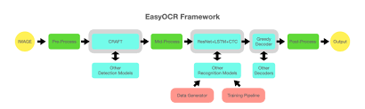

**Image Input**: The process commences with providing an image containing text as input to the EasyOCR model. This image can be in various formats such as JPEG, PNG, etc., and serves as the basis for subsequent text extraction operations.

**Preprocessing**: Prior to feeding the image into the OCR model, preprocessing steps are applied to optimize the quality of the image and prepare it for effective text extraction. These preprocessing steps encompass tasks like resizing, normalization, noise reduction, and binarization, which collectively enhance the clarity and suitability of the image for text analysis.

**Text Detection:** The initial stage in text extraction involves identifying the regions within the image where text is present. EasyOCR employs sophisticated algorithms and neural networks to accurately detect these areas, typically by outlining bounding boxes around the text regions. This precise localization facilitates subsequent text recognition processes.

**Text Recognition**: Once text regions are identified, the OCR model proceeds to segment the text contained within these bounding boxes and recognize individual characters and words. Leveraging deep learning techniques, particularly Convolutional Neural Networks (CNNs), EasyOCR effectively deciphers the text, ensuring accurate extraction and interpretation.

**Language Processing**: EasyOCR boasts support for multiple languages, necessitating language processing to ensure accurate interpretation of the text based on the specified language. This crucial step ensures that the extracted text is not only accurately transcribed but also retains its intended meaning, catering to diverse linguistic requirements.

**Post-processing**: Following text recognition, post-processing techniques may be applied to refine the extracted text further. These techniques encompass tasks such as spell checking, punctuation correction, and text normalization, all aimed at enhancing the overall accuracy and readability of the extracted text output.

**Output**: Ultimately, the extracted text is presented as output, typically in the form of a string or structured data, depending on the application's requirements. This extracted text serves as valuable data that can be utilized for various purposes, including indexing, searching, or further analysis, thereby facilitating informed decision-making and enhancing overall efficiency.

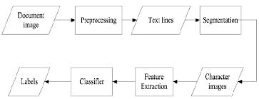

**Literature Review**

Various studies have explored the use of OCR technologies for text extraction from images, with EasyOCR emerging as a popular choice due to its simplicity and effectiveness. Additionally, research in facial recognition, gender and age detection, and action recognition has laid the groundwork for integrating these functionalities into assistive devices for the visually impaired.

**Implementation**

In the implementation phase, the focus is on integrating EasyOCR into the Artificial Eye platform. This involves developing software modules that interface with EasyOCR to capture and process images, extract text, and convert it into speech for auditory feedback to the user. The implementation also includes algorithms for gender and age detection, as well as action recognition, utilizing computer vision techniques for accurate analysis of visual data.

**Result**

Preliminary testing of the implemented system demonstrates promising results in text extraction from images using EasyOCR. The system accurately interprets text from various sources, including signage and printed materials, providing visually impaired users with access to critical information. Further testing is underway to refine the system's performance and integrate additional functionalities such as facial recognition and action detection.

Install Core Dependencies : PyTorch.

After installing the PyTorch library successfully it’s quite easy to install the EasyOCR library, one just has to run the following command:

pip3 install easyocr

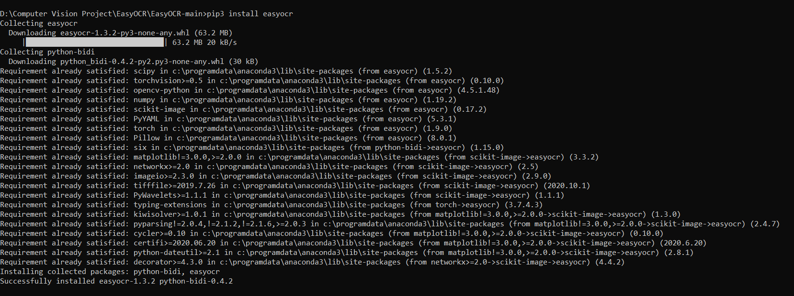

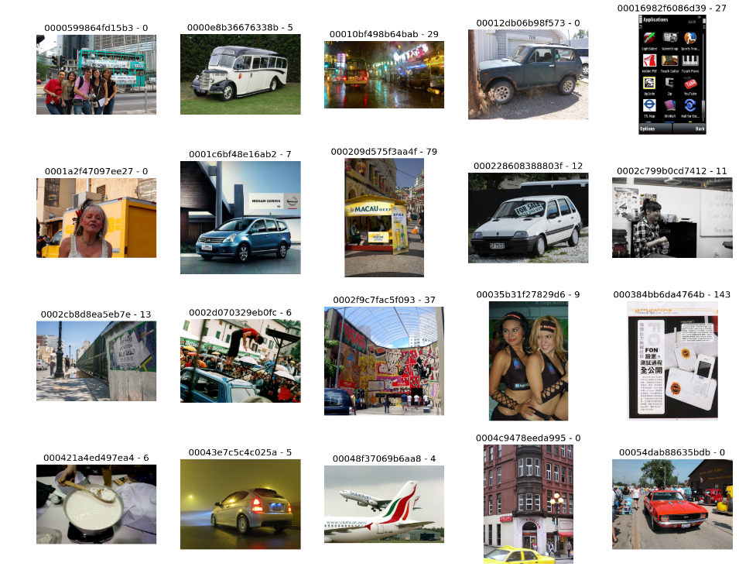

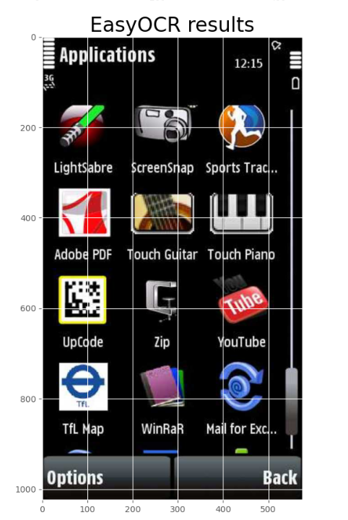

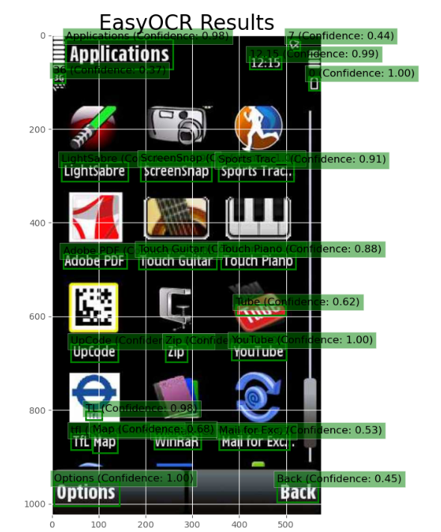

**Conclusion**

The integration of EasyOCR into the Artificial Eye represents a significant step towards enhancing the independence and autonomy of visually impaired individuals. By providing real-time access to textual information from images, along with capabilities for facial recognition, gender and age detection, and action recognition, the system enables users to navigate their surroundings confidently and interact with others more effectively. Continued development and refinement of the technology hold the promise of further improving the quality of life for the visually impaired community.

**Future Implementation**

In our future implementation, we plan to integrate the Google Text to Speech (gTTS) library in Python to enhance the auditory capabilities of our system. The gTTS library offers the functionality to convert text into audio, enabling us to provide spoken feedback to the user. This feature will be particularly useful for visually impaired individuals, as it allows them to receive information through auditory channels.

Moreover, the gTTS library provides options to customize the speech output, including the ability to adjust the speed of speech delivery. This customization ensures that the speech output is tailored to the user's individual preferences and grasping level, thereby enhancing the overall user experience.

Additionally, we aim to implement text-to-speech conversion using a novel approach that involves storing various font and text images in patterns. By employing matching algorithms, we can accurately distinguish between text images, character by character, and convert them into speech. This approach not only improves the accuracy of text recognition but also enables us to handle diverse fonts and text styles effectively.

In conclusion, our future implementation of the Artificial Eye technology will encompass multiple features, each offering distinct functionalities. These functionalities include action and object detection, image-to-speech conversion, and facial recognition. By integrating these features seamlessly, we aim to create a comprehensive assistive device that empowers visually impaired individuals to navigate their surroundings independently and confidently.